Romania - Macroeconomic Situation

July 2004

Summary

Romania has continued to demonstrate robust economic growth since the beginning of the year. During the first quarter of 2004, gross domestic product (GDP) grew by 6.1% year-over-year (yoy) supported by strong growth in industry and construction activities. High growth in industry continued through the second quarter of 2004. A substantial expansion of the production of chemicals, wood processing and metallurgy contributed to the 4.6% yoy growth of industrial production in January-May. Inflation remains the main tenet of the Central Bank's decision making, and it intends to bring inflation down to 9% by the end of 2004. In June the annual inflation rate stood at 12.0% yoy, down from May’s 12.3% yoy. In June, the central bank hard currency reserves (excluding gold) rose to EUR7.8 billion, equivalent to 3.8 months of imports of goods and services. The current account deficit reached EUR1.13 billion for the first five months of the year, 16.4% higher yoy, mainly reflecting a growing trade deficit. On July 7, the Board of IMF approved a two-year, SDR250 million ($367 million) Stand-By Arrangement with Romania.

Economic growth

Since the beginning of the year, Romania has enjoyed a robust economic recovery. During the first quarter of 2004, gross domestic product (GDP) grew by 6.1% year-over-year (yoy) underpinned by strong domestic demand and investment growth. Over the period, final consumption increased by 8.1% yoy and was one of the main drivers of economic growth. Gross capital formation also grew at a high pace, increasing by 7.3% yoy in the first quarter of 2004.

The construction sector was the fastest growing sector, with value added growing by 7.2% yoy (compared to 7.0% yoy in 2003.) The robust performance of the construction sector was supported by high demand for both residential and commercial facilities and by favorable interest rates. Favorable weather conditions encouraged a 5.4% yoy growth in value in agriculture over the same period. Value added in industry picked up 6.6% yoy in the first quarter mainly due to strengthening domestic demand.

Industrial Output Growth by Sector, yoy % change
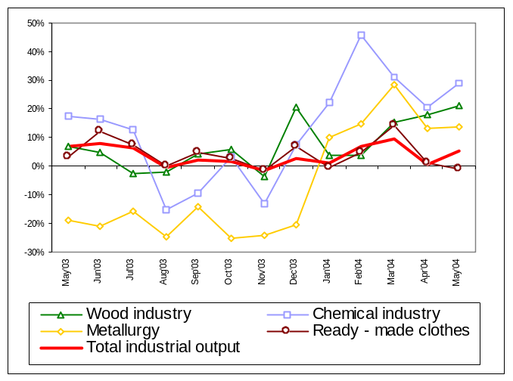
Source: National Statistics Board (INSSE), Intellinews

High growth in industry continued through the second quarter of 2004. In January-May industrial production increased 4.6% yoy. Industrial output in May was up 5.2% yoy primarily due to sharp rebound in manufacturing. On product breakdown, the growth leaders in industry were chemicals, wood processing and metallurgy. Robust external demand for plastic and rubber products underpinned a 29% yoy leap in chemicals output in the first five months of 2004. Following a long period of stagnation in metallurgy, growth in the sector recovered in 2004. During January-May, metals production expanded by 16% yoy fueled by strong external demand. Wood processing (excluding furniture production) has made sizeable contribution to the overall pickup in industry, growing by 12.7% yoy. In January-May, production of ready-made clothes, the major export-oriented industry of Romania, increased by 3.7% yoy, compared to a 3% yoy decline a year ago.

According to the official government forecast, GDP growth is expected to reach 5.5% yoy for the entire 2004 year. Based on the actual industrial performance in the first five months, the governmental expectation looks quite realistic.

Fiscal Policy

Since the beginning of 2004 the Romanian Government has maintained prudent fiscal policies. Over the first five months of 2004, the Ministry of Finance reported a consolidated budget deficit of 0.2% of expected full-year GDP (or 0.5% of GDP on an annual basis). This favorable outcome was the result of an increase in both revenues and expenditures by 11.7% yoy and 9.7% yoy in real terms, respectively. Over January-May, the primary budget recorded a surplus of 0.4% of GDP, while the relatively small consolidated budget deficit leaves the government with a broad margin for attaining this year’s target of a consolidated budget deficit of 2.1% of GDP (down from 2.4% last year), in line with the recent agreement with the IMF.

Consolidated Budget Balance, % of GDP
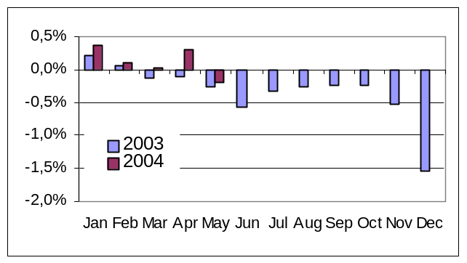
Source: Ministry of Finance

The Government has recently approved an adjustment to the 2004 budget, with the agriculture, education and health receiving the biggest part of the planned increase in spending of ROL6,800 billion (approximately $200 million). Some ROL850 billion ($25 million) were earmarked for agricultural subsidies, ROL800 billion ($24 million) will be used to construct additional sports halls and subsidized housing for youth. On the other hand, the Government rejected the request for salary increases by the trade unions of public employees. The additional budget expenses would be possible due to a lower cost of public debt service; thus, the targeted budget deficit for 2004 remains unchanged at 2.1%, as agreed with the IMF.

Monetary Policy

Monthly inflation in June stood at 0.6% month-over-month (mom), up from 0.3% mom in May, thus putting the year-to-date figure at 3.7%. In June, prices in food and non-food products gained 0.4% and 0.6%, respectively, while prices in the services sector advanced 1.2%. By June, annual inflation stood at 12.0% yoy, down from May’s 12.3% yoy. Inflation remains the main tenet of the Central Bank's decision making. In accordance to its agreement with the IMF, the government intends to bring inflation down to 9% by the end of 2004.

CPI and Broad Money (M2) Growth, yoy % change
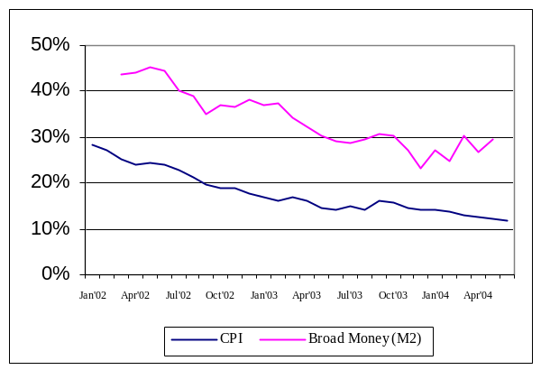
Source: INSSE, National Bank of Romania (BNR)

In July, the Central Bank cut the intervention rate by 0.75%, to 20% for one-month deposits attracted by banks. This intervention rate is above the 18.25% rate registered a year ago. The Central Bank had followed a cautious approach before every rate cut, involving assessment of macroeconomic trends, and avoiding building expectations in the market regarding the frequency and extent of each adjustment. However, the small interest rate cut in June 2004 hinted a new approach based on small rate adjustments taken relatively often, with the aim of narrowing the gap between the interest rate and the inflation rate. However, bankers do not consider this move to have a significant impact on their lending and savings operations, given the competitive environment in the sector in which banks focus on commercial strategies that can secure them a loyal client base.

The expansions of money supply and domestic credit remain major problems for the country, contributing to a high balance-of-payment current account deficit as discussed below. According to the Central Bank, in May 2004 broad money (M2) expanded by 29.4% yoy to ROL491 trillion ($14.7 billion). This represented an acceleration from the 26.9% yoy growth in April. Net foreign assets increased 23% yoy to ROL268 trillion ($8.0 billion), due to an increase in the Central Bank’s convertible currency position. Net domestic assets were up 39% yoy, reaching ROL222 trillion ($6.6 billion). On the liability side, narrow money supply (M1) advanced 40% yoy to ROL119 trillion ($3.6 billion), as cash in circulation picked up 30% yoy and demand deposits gained 54.5% yoy. Quasi-money increased 26.4% yoy to ROL372 trillion ($11.1 billion), with household savings increasing 18% yoy to account for 20.8% of broad money. The currency structure of deposits changes only gradually because households prefer to use foreign currencies as mean to store value. The share of foreign currency deposits in the total deposits is equal to around 49%, almost unchanged over the last two years. Despite the Central Bank’s efforts to reduce currency substitution, the national currency may gain more confidence as the authorities succeed in reducing inflation to single digit levels, as agreed with the IMF.

Table: Money Supply (ROL trillion)
 | May 04 | April 04 | May 03
Money Supply (M2) | 490.5 | 481.5 | 378.6
yoy % change | 29.4 | 26.9 | 30.4
Net Domestic Assets | 222.1 | 212.9 | 160.0
yoy % change | 38.6 | 33.0 | 79.4
Net Foreign Assets | 268.4 | 267.4 | 219.0
yoy % change | 22.7 | 22.1 | 8.8
Source: BNR, own calculations

In accordance with the agreement with the IMF, the government expects that growth in domestic credit will be reduced to 35% in 2004, down from 55% last year. However, by May domestic credit growth had accelerated to 40.2% yoy to ROL336 trillion ($10.0 billion), primarily on the account of non-government credit. In May credit to the non-government sector grew at a high rate of 57% yoy, compared to 54% yoy in April. About 57% of the portfolios of the bank represent loans denominated in foreign currency. In May, the stock of foreign denominated credit grew 52% yoy to ROL195 trillion, partly due to Romanian lei depreciation against US dollar.

The holdings of government securities by the non-banking sector stood at ROL53 trillion ($1.8 billion), down 1.9% from end-April. At end-May the holdings of hard currency T-bill by the non-banking sector gained 3.8% mom, reaching the equivalent to EUR164 million.

Since the beginning of 2004, the BNR has been building up its international reserves by making consecutive purchases from the local forex market. In June, the Central Bank’s hard currency reserves (excluding gold) rose EUR492 million to EUR7.8 billion. This sum is equivalent to 3.8 months of imports of goods and services, which conforms to the IMF safety margin for foreign reserves. The rise in reserves was due to the Central Bank’s purchases of EUR430 million in the foreign exchange market, the inflows of EUR180 million from the privatization of Banca Comerciala Romana, reserve management revenues of EUR7.0 million, and other net inflows of EUR32.5 million. The main outflows comprised payments to service public and publicly guaranteed debt of EUR157 million. Payments on external debt both direct and guaranteed by the Ministry of Finance, and due by end-2004 run at EUR682 million. The Central Bank expects the FX reserves to continue their upward trend due to expected inflows of foreign funds due to several high profile privatizations.

Foreign Reserves: M-o-M Change and Total (January 2003- June 2004)
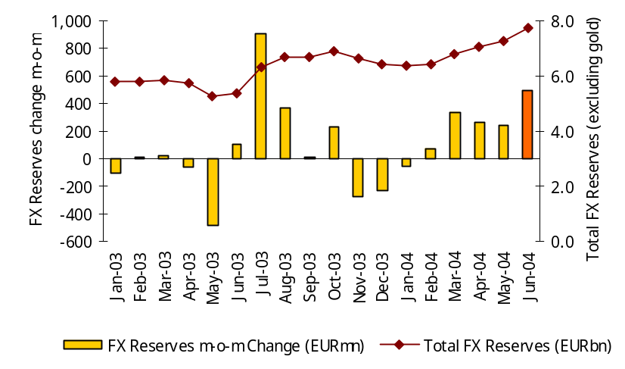
Source: BNR, own calculations

As of the end of May, the country’s total foreign debt, including foreign private debt and public and public guaranteed debt, stood at EUR16.1 billion, up 3.7% yoy. The increase was due to a 6.8% growth in the private debt and a 4.4% increase in the publicly guaranteed debt, while the public debt remained almost unchanged at EUR6.5 billion.

International Trade and Capital

In May 2004, merchandise exports increased by 23.8% yoy and 5.3% mom, reaching EUR1.6 billion. Merchandise imports were up 22.6% yoy and 12.7% mom, reaching EUR2.2 billion. During the period January-May, merchandise exports stood at EUR7.4 billion, 18.4% higher yoy. Textiles, machinery and equipment, metallurgical products, mineral products and footwear accounted for 69.7% of total exports over the period. Imports over the first five months of 2004 stood at EUR10.0 billion, or 20.2% higher yoy. Machinery and equipment, textiles, minerals, automotive and chemicals products accounted for a combined 66.5% of imports over the January-May 2004 period. The trade deficit over the first five months of 2004 stood at EUR2.3 billion, up EUR482 million, or 26.3% yoy. EU markets accounted for 73.3% of Romanian exports and 64.6% of imports during the same period, with Italy remaining the top-trading partner (22.0% of total exports, and 17.9% of total imports).

Romania’s Foreign Trade Performance
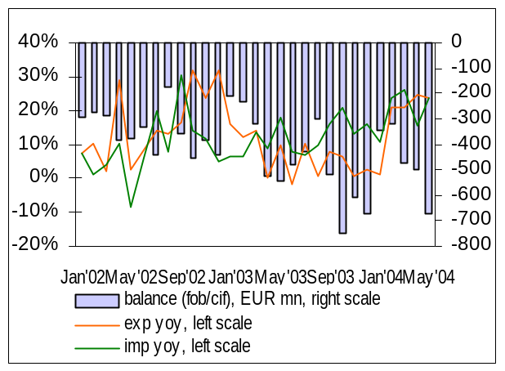
Source: INSSE, own calculations

The Current Account (CA) deficit reached EUR1.13 billion for the first five months of the year, 16.4% higher yoy, mainly reflecting the country’s large trade deficit as discussed above. While all categories of services (except for transportation) also recorded negative balances, transfers increased 34.3% yoy, mainly due to increased remittances from workers abroad. In 2003, the CA deficit reached EUR2.9 billion, representing 5.8% of GDP.

The level of foreign direct investment (FDI) to Romania in the first five months of 2004 reached $753 million (EUR616 million), up 7.2% year-to-date (ytd.) During May foreign investments amounted to $106.2 million. Like in previous months, Italian investors were the largest ones, followed by German and Hungarian investors. FDI amounted to $1.5 billion in 2003. In 2004 the Romanian authorities hope to register a growth of 30- 40% yoy. This should be driven by the privatizations of SNP Petrom (oil and gas, integrated), Banca Comerciala Romana (banking) and companies in the energy sector. At end of May 2004, the cumulative amount of total foreign direct investment in Romania exceeded $11.2 billion.

During the first half of 2004, net foreign portfolio investments recorded a value of EUR24.1 million up 12% yoy. Over the last few months, several international funds have redirected their portfolio investments from the Czech Republic and Hungary toward Romania and Bulgaria. Beside the bourse potential, foreigners are also attracted by high ROL-denominated interest rates as compared to the rates available on international markets. However, local investors still account for over three quarters of the trading volume on BSE.

International Programs

Romania has now finalized the EU accession negotiation chapter on Energy, thus raising the number of closed chapters to 25, with five more remaining to be closed this year. The closure of the Energy chapter raises perspectives of achieving for Romania the EU status of a “functioning market economy” this fall. In the recent past, the energy sector was a major source of arrears in the Romanian economy, which was a major problem for the status as a market economy. According to Romanian officials measures have already been taken to reduce arrears and to prevent new ones to accumulate. Romania needs to close five more chapters in order to finalize negotiations with the EU this year, in time for the planned accession in 2007. It is not clear, however, whether this target will be achieved. While the Dutch EU President has said that it is too early to say whether Romania will be able to close all the negotiation chapters by the end of the year, the EC Chairman has expressed optimism regarding to this schedule.

On July 7, the Board of IMF approved a two-year, SDR250 million ($367 million) Stand-By Arrangement with Romania. The Romanian government is treating the arrangement as precautionary and does not intend to make any drawings, unless urgently needed. As part of the program, authorities intend to reduce the 2004 consolidated budget deficit to 2.1% of GDP, down from the 2.4% last year. Under the IMF program, the Romanian authorities expect credit growth to slow down to 35% in 2004 from 55% last year, thus curbing domestic demand and causing the current account deficit to decline to 5.25% of the GDP from 5.9% in 2003. With respect to monetary policy, the agreed target for 2004 is reaching single digit inflation. The Romanian authorities are also expected to accelerate privatization, the current program making a special reference to SNP Petrom privatization. The current arrangement follows the successfully closing by Romania last year, for the first time since 1990, of a Stand-By Arrangement.

