Ukraine - Economic Situation
October 2008
Olga Pogarska, Edilberto L. Segura
Summary

- Ukraine’s real economy has continued to perform well with a real rate of GDP growth of 6.9% yoy in January-September 2008. However, Ukraine’s near term outlook has worsened substantially but medium-term prospects remain good.
- Over the nine months of 2008, consolidated budget was in surplus of UAH 11.8 billion ($2.3 billion) or 1.6% of period GDP, backed by above-target revenues and tight control over expenditures. With the gloomy prospects to fully fill the planned financing gap and the likely shortfall in revenues through the rest of the year, the government started to revise their expenditure plans. As a result, fiscal deficit is likely to be significantly below the target.
- Following two months of inflation relief, consumer prices returned to growth, advancing by 1.1% month-over-month in September. Though in annual terms, inflation continued to decelerate, government plans to adjust a number of service tariffs will notably hinder this process in the coming months.
- With rapidly widening trade and current account deficits, large external debt financing needs and high banking system exposure to credit and foreign currency risks, Ukraine was and remains extremely vulnerable to adverse external shocks. On the bank of heightened global financial instability since September, falling world steel prices and weakening global economy, these risks started to materialize during September-October.
- Reflecting growing stress to Ukrainian economy, major international rating agencies downgraded Ukraine’s sovereign rating.
- Despite the recent turbulences, the prompt government and monetary authorities’ response as well as gained support from international financial institutions increases chances Ukraine may be able to weather the storm with relatively moderate pain.

Economic Growth

Buoyed by an outstanding performance in agriculture, Ukrainian real GDP growth picked up to an impressive 10.4% yoy in August, bringing the cumulative growth to 7.1% yoy. At the same time, Ukrainian economy is likely to loose steam through the rest of this year and also 2009, courtesy of both external and domestic factors. Resilient so far, heavily export-oriented and external-financing-dependent Ukrainian economy looks increasingly vulnerable to the recent financial crisis. Weakening external demand has already manifested through plunging world commodity prices, while foreign investors’ flight-to-quality and risk aversion risk drying up foreign capital inflows to emerging markets. On the domestic front, lingering inflationary pressures and political instability, weaknesses in the domestic banking system, rapidly widening trade deficit and large private sector indebtedness subdue Ukraine’s economic outlook in the near future.

Contributions to Real GDP Growth by Value Added, percentage points

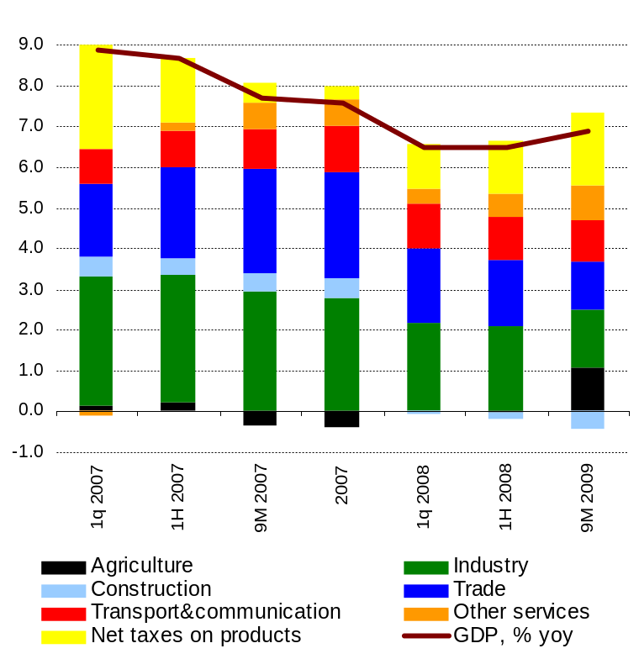

Source: State Statistics Committee of Ukraine, The Bleyzer Foundation

Already in September, real GDP growth slowed to 5.5% yoy on the back of weaker industry, domestic trade and construction performances. Cumulatively, however, economic growth decelerated only marginally to 6.9% yoy, supported by strong value added growth in agricultural and the transportation and communication sectors. Thanks to 15-year record grain harvest, agriculture expanded by 15.7% yoy over the nine months of the year. At the same time, due to unfavorable weather conditions in September, the harvest of corn, sugar beats and some other crops and vegetables turned out to be less successful than it was previously expected. This explains value added growth deceleration in January-September compared to an explosive 24.4% yoy increase in January-August. Transportation and communication kept expanding at a robust 10.4% yoy over January-September, virtually the same rate as in 1H 2008, according to the revised State Statistics Committee data.

Industrial Output by Selected Branches in 2006-2008, % yoy cumulative

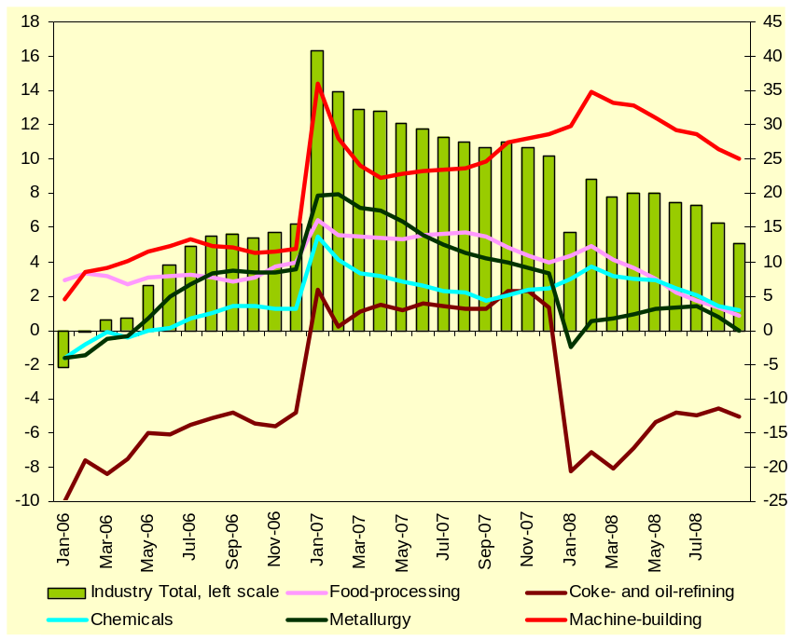

Source: State Statistics Committee

On the other hand, construction plunged by 10.3% yoy over the nine months, affected by tight access to credit. The industrial sector also continued to decelerate and grew only by 5% yoy due to weaknesses in the global demand for iron, steel and chemical products. In particular, following several months of deceleration, metallurgical production has been contracting in annual terms since August in line with the sharp decline in world steel prices. In September, output in the industry fell by 17% yoy, driving the cumulative growth below zero. October is likely to see another major decline in the industry as a number of metallurgical producers announced production and employment cuts.

Depression in the metallurgical sector will exact a significant toll on the whole Ukrainian economy as the sector accounts for more than 45% of total export revenues and about 25% of total industrial production. In addition, poor metallurgical performance will also affect a number of other industries and sectors, including extractive industry, machine-building, construction, and transportation. Expectations that new harvest will improve food processing performance did not materialize. The industry production grew by modest 2.2% yoy over the nine months of the year, decelerating from about 10% yoy at the beginning of the year. Weak external demand was among the main reasons of worsening chemical industry performance. Over the nine months, output growth in export-oriented chemical production slim down to 2.9% yoy compared to 9% yoy growth at the beginning of the year.

Contributions to Real GDP Growth by Expenditure, percentage points
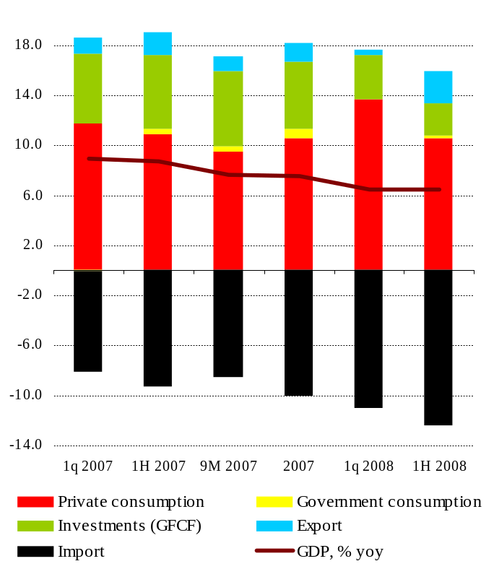
Source: State Statistics Committee, The Bleyzer Foundation

After all, warning signs of economic weakness were already evident in the second quarter of 2008. In particular, investments advanced by only 6.3% yoy as tighter monetary policy limited access to banks’ credit. Private consumption growth decelerated to 13.3% yoy, down from almost 18% yoy in the previous quarter. Domestic trade slowdown to 9.4% yoy in January-September from 13% yoy in 1H 2008 foretells further weakening of the domestic consumption in 3Q 2008. Moreover, while exports rebounded at strong 9% yoy (up from less than 1% yoy in 1Q 2008), imports continued to outpace exports, expanding by a record high 25.6% yoy in 2Q 2008. Ukraine’s deteriorating current account balance puts pressure on economic growth and increases country’s dependence on external capital flows.

On the back of easing steel prices, tight external and domestic credit markets amid large external financing needs, cooling world economy and recent turbulences at domestic financial market, which are likely to cause further credit squeeze and aggravate domestic banking sector weaknesses, Ukraine’s near-term outlook has worsened substantially. The Ukrainian economy is forecasted to decelerate to 6.3% yoy in 2008 enter a downturn in 2009. At the same time, the country maintains good medium-term outlook, supported by large domestic market, great agricultural potential, cheap and skilled labor force, good prospects for signing FTA with the EU and greater chances of reform acceleration (in part, thanks to applying recently to the IMF financing).

Fiscal Policy

Ukraine’s public finances remained in a good shape as the country ran a consolidated budget surplus of UAH 11.8 billion ($2.3 billion) though the end of September, which is equivalent to 1.6% of period GDP. Public spending rose by nominal 41% yoy over the nine months of the year, underpinned by higher spending on public wages and social transfers. In particular, remuneration to public sector employees grew by nominal 38.1% yoy, while current transfers to the population advanced by 48% yoy. Despite strong growth, fiscal expenditures were still below the target mainly due to under-execution of capital spending. The government refrained from tightening social expenditures in view of turbulent political environment and looming presidential elections (scheduled for early 2010). At the same time, though expenditures notably increased, they were still below the targeted amount. According to State Treasury, expenditures from the general fund of the state budget were under-executed by about 3%. Together with above-planned revenues, this secured budget surplus for the period.

Consolidated Budget Balance, % of period GDP

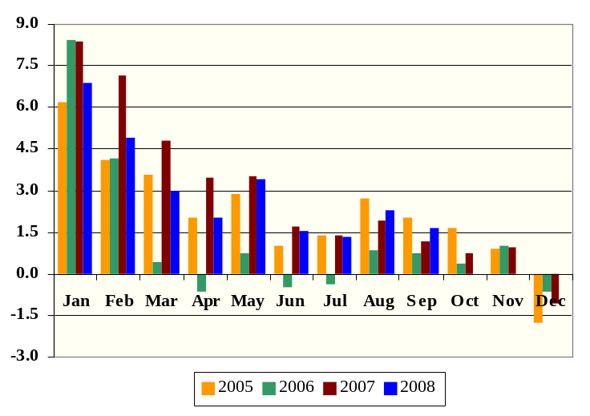
Source: Ministry of Finance

During January-September, consolidated budget revenues grew by 43.7% yoy in nominal terms over the nine months of the year backed by 53% yoy increase in tax receipts. As in the previous periods, value added tax proceeds, advancing by almost 70% yoy in nominal terms, were the main contributor to the tax revenues growth over the period. Defined usually as the tax on consumption, impressive growth in VAT receipts this year is explained by high inflation, robust imports, and improved tax administration. In parallel, however, the authorities started to accumulate VAT refund arrears, as already in the middle of the year it became clear that the targeted amount for VAT refunding, envisaged in the 2008 budget law, was significantly underestimated. In January-September, VAT reimbursement was 43% above the planned amount. According to expert estimates, VAT refund arrears amounted to UAH 11 billion (about $2 billion) as of end-September, up from about UAH 8 billion in the middle of the year. Situation, however, is unlikely to improve till the end of the year, as a reduction in arrears will require budget revision, the likelihood of which looks quite low. At the same time, the accumulation of further arrears may loose speed substantially through the rest of the year given notable export weakening. Execution of other taxes, particularly corporate and personal income taxes, has been good in January-September, as proceeds from these taxes picked up by nominal 57% yoy and 38% yoy respectively.

Despite current favorable budget performance, successful budget exercise through the rest of the year looks quite worrisome. First, due to projected further worsening of economic performance through the rest of the year and government initiatives to introduce tax benefits for a number of industries affected by a sharp deterioration in external environment, budget revenues risk to be substantially under-executed. Though, a good point is that above-target revenues and strict control over expenditures allowed the government to accumulate significant cash balances at its Treasury account (about UAH 16 billion at the end of September). Second, the financing gap, targeted at about UAH 19 billion, or 1.8% of expected 2008 GDP, looks insurmountable to fill. Budget deficit was planned to be financed by new government borrowings (both external and internal) and privatization proceeds. Despite the greater reliance on domestic debt financing this year, Ukraine’s fiscal authorities still planned to raise UAH 8.1 billion ($1.6 billion) in foreign borrowing, including about $1 billion by placing Eurobonds, for which a road-show was conducted in June. However, on the back of tight external credit markets and investors’ flight to safety, the government decided to shelve the bond issuance. At the same time, reliance on domestic debt issuance also was not very successful. Given frankly unattractive yields amid high domestic inflation, the authorities raised only UAH 1.4 billion into the state coffers in January-September, or less than 20% of the targeted for this year amount. And finally, government plans to receive UAH 8.8 billion ($1.5 billion) in the form of privatization receipts this year will not materialize. As of end-September, the accumulated privatization proceeds amounted to less than 4.5% of the annual target.

With the deteriorating prospects for already slowing Ukrainian economy and the lack of targeted fiscal deficit financing, the government started to revise their expenditure plans. In particular, the President and the Cabinet of Ministers issued a number of Decrees, envisaging expenditure cuts on public administration. Moreover, the government is likely to continue to tightly control expenditures through the rest of the year. This would mean moderate expenditure loosening in the last couple of months. Hence, the end-year fiscal deficit may turn to be significantly lower than it was previously expected.

Presented in September draft Budget Law for 2009 are likely to be recalled or significantly amended, as it was developed prior to financial stresses at both external and domestic markets and deteriorated prospects for the next year. Moreover, the targeted deficit of UAH 17.4 billion ($3 billion), or 1.4% of GDP, disaccord the government commitment to the IMF to maintained a balanced budget in 2009. Prudent fiscal stance is considered as the most effective measure to cool aggregate demand, tackle inflation and narrow foreign trade deficit. Given turbulent political environment, it looks as if the 2009 budget law is approved already next year.

CPI, Money Supply and Commercial Bank Credits, % yoy
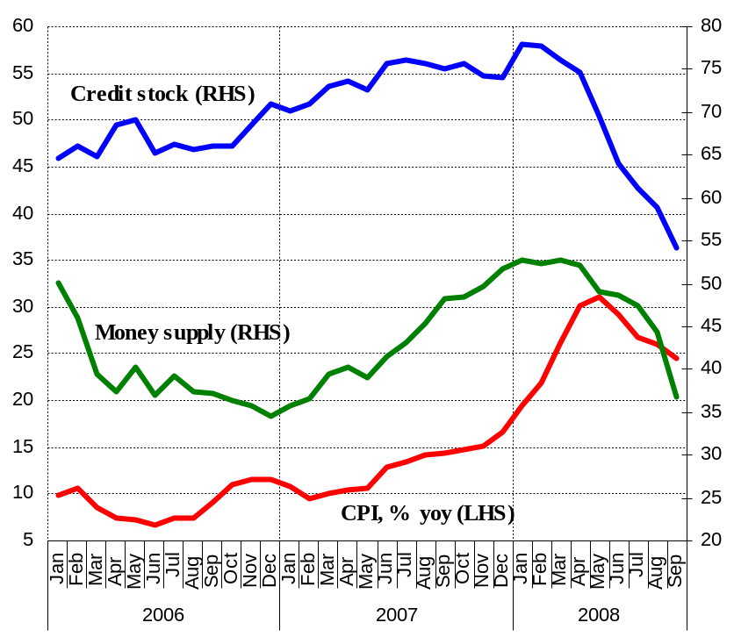
Source: State Statistics Committee, The Bleyzer Foundation

Monetary Policy

Monetary policy tightening, appreciation of the national currency in May, and record high harvest caused prices to fall during July-August. As a result, annual inflation continued to decelerate reaching 26% yoy in August, down from its peak of 31.1% yoy in May. However, tow-month deflation was a temporary relief as already in September, monthly inflation advanced by 1.1%. On a high statistical base, however, in annual terms inflation kept slowing to 24.6%. A rise in monthly inflation reflects a 3.8% mom increase in utility tariffs (starting September, natural gas prices for population were increased by 13-14%), 21.2% mom growth in the cost of education services and 1.2% mom more expensive services in restaurants and hotels and higher excises on tobacco. Some relief was brought by declining gasoline prices (down by 6% mom in September) consistent with falling world crude oil prices. While inflation is expected to decelerate further till the end of the year, its pace will be much slower. First, easing inflation provided the government authorities with some room to adjust a number of regulated prices and tariffs. A 20% rise in communication tariffs since the beginning of October, another 35% increase in natural gas tariffs for households since the beginning of December, and several times increases in utility tariffs for legal entities and transportation tariffs in Kyiv, the capital and the largest city of Ukraine, were already announced. Second, recent sharp depreciation of the national currency may spill-over into domestic inflation as it will make imported goods more expensive. Though substitution effect will be present, it may be quite limited for a number of inelastic goods such as medicines, energy, etc. Annual inflation is expected to slow moderately to about 22% yoy in 2008.

Unfavorable sentiments formed amid recent intensification of global financial turmoil and deteriorating Ukraine’s fundamentals prompted foreign investors to more actively withdraw its capital from Ukraine. A combination of falling world steel prices and weakening external demand, large current account deficit and sizable payments due on private sector external liabilities, weaknesses in the banking system (high exposure to credit and foreign exchange risks) as well a new wave of political instability since September tilted the balance towards sharp Hryvnia depreciation. The NBU refrained from active support of the exchange rate, allowing it to depreciate, which was consistent with May’s decision to switch towards managed float regime. The NBU, however, wanted to smooth exchange rate adjustment to its market clearing level by selling limited amounts of foreign currency in the interbank foreign exchange market. This strategy resulted in a loss of $4.5 billion in the NBU’s foreign exchange reserve during September-October and in a depreciation of the Hryvnia by about 27% of its value against the US dollar over the period (to UAH/USD 5.95 on average at the interbank market at the end-October).

Average UAH/USD interbank exchange rate and NBU interventions
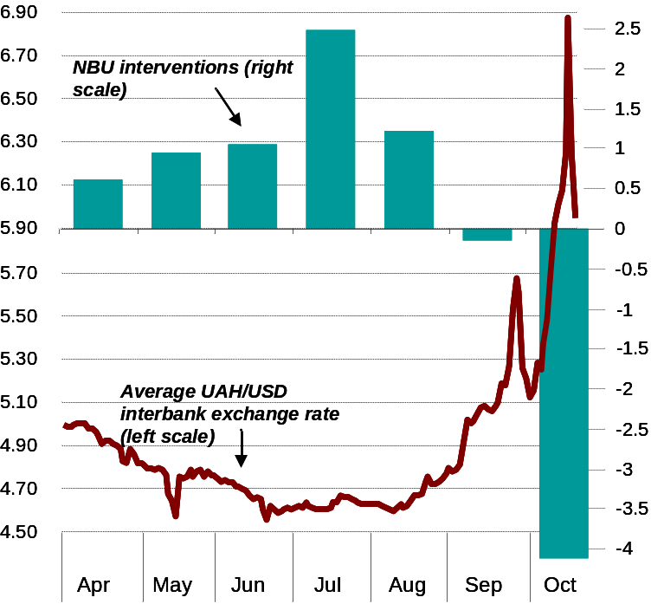
Source: NBU, Finance.ua, The Bleyzer Foundation

Devaluation may also intensify stress on the banking sector due to existing currency mismatches of banks’ assets and liabilities. Though the level of indebtedness of the Ukrainian private sector is far below than in the developed countries, more than a half of all loans issued by the commercial banks are denominated in foreign currencies. This means that local borrowers are particularly exposed to currency risks. On top of that, the six-largest Ukrainian bank has suffered a bank-run by depositors in September. Though the National Bank of Ukraine responded quickly by providing UAH 5 billion (about $1 billion) of emergency refinancing and later took control over this bank, this occurrence undermined confidence into the banking system. To minimize counterparty risks in the banking sector commercial banks cut or closed their bilateral credit limits, restraining commercial bank access to domestic finances. In addition, population rushed to withdraw funds from their deposit accounts. The NBU active support of a number of commercial banks with liquidity through its refinancing operations calmed down these fears. In October, it provided UAH 29.3 billion (about $5 billion).

To avoid bank-runs, the NBU has imposed a six-month freeze on the early withdrawal of saving deposits from the commercial banks. Simultaneously, deposit guarantee was suggested to lift to UAH 150,000 (about $25,800), tripling from the previous level. The NBU has also imposed tight limitations on the capacity of the commercial banks to expand their credit portfolio. Though, a few days later, the NBU softened this restriction, trying to avert local credit crunch, the ban on foreign currency loans to borrowers without foreign currency income was left intact. The NBU strengthened its monitoring capacity of external private sector debt. In particular, it required commercial banks to report data on their and their clients’ external liabilities maturing each quarter over the next 12 months. Government officials have also considered the establishing of a stabilization fund, which would work with a government-owned Asset Recovery Company to buy and resolve some of the distressed assets of the banks. Ukrainian authorities applied for the IMF financing support and on October 26th, an agreement was reached on a two-year $16.5 billion stand-by IMF loan. Given the above measures and support from the international financial institutions, Ukraine still may weather the storm with relatively moderate pain.

International Trade and Capital

Merchandise Trade Performance
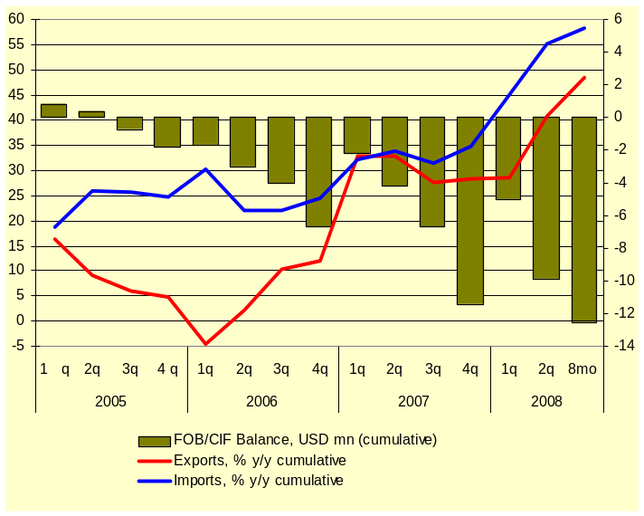
Source: State Statistics Committee
Ukraine’s foreign trade data, released by the State Statistics Committee for January-August, still demonstrate rather favorable picture. Exports kept increasing fast, advancing by an impressive 48.5% yoy over eight months of the year. An outstanding harvest triggered a surge in grain exports, which expanded by 120% yoy over the period. High world iron ore, coal and energy prices over the period underpinned almost 70% yoy increase in mineral products exports, which share grew to 10.4% of total merchandise exports, up from 9% in the respective period last year. Weakening of world steel prices, which was observed since July, had a minor impact on Ukraine’s exports of metallurgical products in August. Export of the weightiest group of commodities surged by 60.6% yoy, bringing the cumulative growth to 54.5% yoy. Robust economic growth in Ukraine’s main trading partner countries supported 40.5% yoy increase in exports of machinery and transport equipment. At the same time, already in August export growth started to decelerate as exports in value terms were by about $1 billion lower in August compared to the previous month.

Though a decline in world iron ore, steel and energy prices, tighter domestic credit conditions and slower growth in real households’ income contributed to a deceleration in import in August, paces of growth remained at an impressive 63% yoy that month (down from almost 70% yoy in July) and 58.3% yoy to date. As imports continued to notably outpace exports, FOB/CIF merchandise trade deficit widened to $12.5 billion over the nine months of this year. Deteriorating foreign trade balance is the main cause of widening current account gap. According to preliminary estimates of the NBU, CA gap widened to $7.5 billion in January-August, representing 6% of period GDP. Over the period under review, this amount was fully covered by foreign direct investments, estimated at $8.1 billion over the period. However, current account gap is expected to reach $12-13 billion, or about 7% of GDP, in 2008. In addition to this, Ukraine will need to serve significant foreign short term debt. As of June 2008, out of total external debt outstanding of $100 billion, about $28.2 billion was due up to one year. At the same time, the NBU reckons external debt by original maturity. This means, that if the short-term portion of the long term debt is included, the total amount of external debt refinancing may be as high as $40-45 billion. Although a portion of this sum is either due by subsidiaries to parent companies or represents more stable trade credits, the net external financing requirements still remain at a substantial $25-30 billion. While this amount looks manageable, amid turbulent global environment marked by risk aversion and worsening Ukraine’s macroeconomic fundamentals raising it may be very difficult, which points to rising stress on Ukraine’s balance of payments. Though official data are not available yet, very high risk premiums on Ukraine’s securities, a decline in portfolio investments, partly as a result of which the country’s stock exchange (PFTS) index has declined by more than 80% year-to-date, and finally sharp currency depreciation during September-October show the above risks started to materialize.

Gross External Debt, by Sectors, $ billion
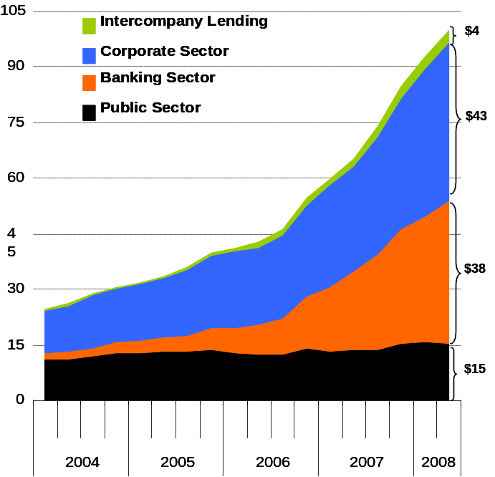

Short-Term External Debt, by original maturity, $ billion
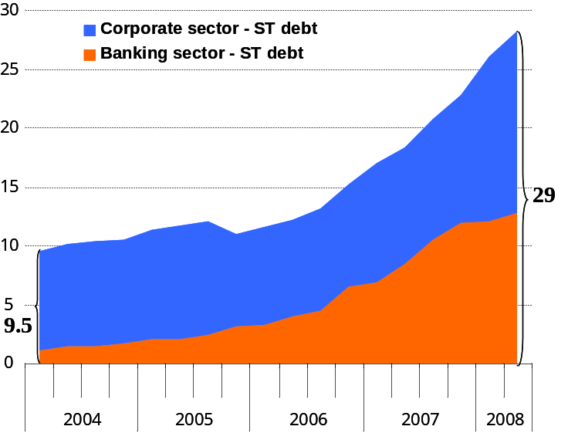
Source: NBU, The Bleyzer foundation
On a positive note, declining world crude oil prices increases chances the natural gas price increase on imported gas in 2009 may be significantly lower than in it was previously anticipated. Coupled with the implementation of a government program developed in close cooperation with the IMF to restore financial and macroeconomic stability, current account pressures will ease substantially. Current account gap is now forecasted to decline to about 3% of GDP in 2009.

Other Developments Affecting Investment Climate

Following rapid deterioration of macroeconomic fundaments, currency pressures and increased worries over banking sector health, international rating agencies downgraded Ukraine’s sovereign ratings as well as individual ratings of a number of private companies and commercial banks.

Ukraine’s sovereign credit rating as of end-October 2008
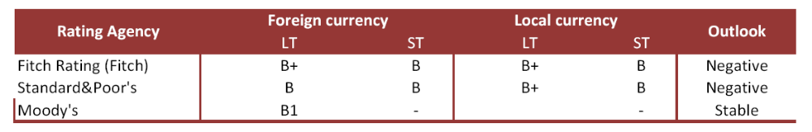

For the same reasons, at the beginning of October the Ukrainian authorities have applied for IMF financial support. On October 26th, a tentative agreement was reached on a two-year $16.5 billion stand-by agreement. The final decision was conditioned on the parliament approval of a number of legislative initiatives, including approval of a bank recapitalization program and a firm commitment to prudent fiscal policy coupled with tighter monetary policy. Despite turbulent political environment, the government authorities promptly developed the “stabilization” package, which was approved by the parliament at end-October. For the Parliament vote to be legitimate, the President has suspended its dissolution order of the Rada. Moreover, early parliamentary elections called by the President at the end of September are likely to be delayed till spring next year. Though the approval of the IMF financial support package is not a panacea, it sends positive signals about the possibility that Ukraine may weather the storm with relatively moderate pain.

The IMF support opens also other alternative external sources of financial assistance to Ukraine. In particular, the World Bank has already announced it is revising its program of cooperation with Ukraine to provide rapid assistance in hot areas, such as restructuring and recapitalization of the banking sector, improving support to the poor, deepening of structural reforms to restore Ukraine rapidly to sustainable economic growth, etc.

